Win10 /Win8系统遇到驱动需要数字签名无法安装问题怎么办？在Win10 /Win8系统中，设备只有安装了驱动才能正常使用，而有时我们发现下载来的驱动程序无法安装，没有数字签名，这显然是系统为了安全问题而阻挡了没有经过认证的驱动安装，不过有些时候一些特殊设备没有通过验证的驱动，那么显然我们只要有暂时关闭数字签名才能正常安装，今天小编就分享一下方法。
Win10 / win8 system can't install USB drive without a digital signature? In Win10 /win8 we found the driver can't install, because no digital signature, it's the system for safety problems, we could install USB driver as long as we have temporarily closed digital signature, method is:
操作步骤：
- 单击开始菜单，然后按住“ SHITF键 ”关点击电源按钮，选择重启；
Click start and hold “shift key” and click power key ,select “restart”;
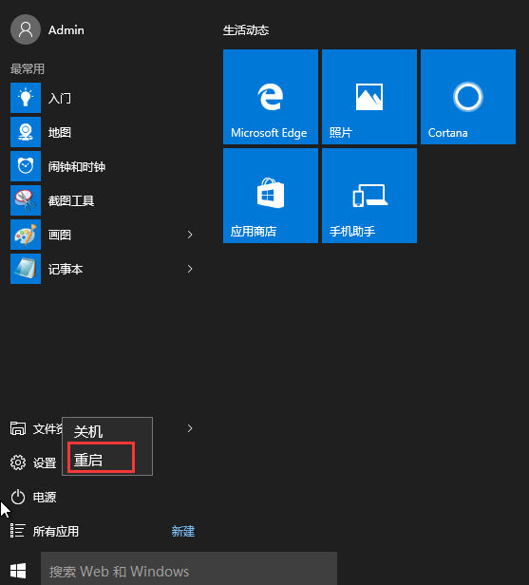

- 重启后，系统进入到“选择一个选项”界面，然后我们再选择“疑难解答”；
When restart, system logo onto a screen show us “problem ,reset,computer”;
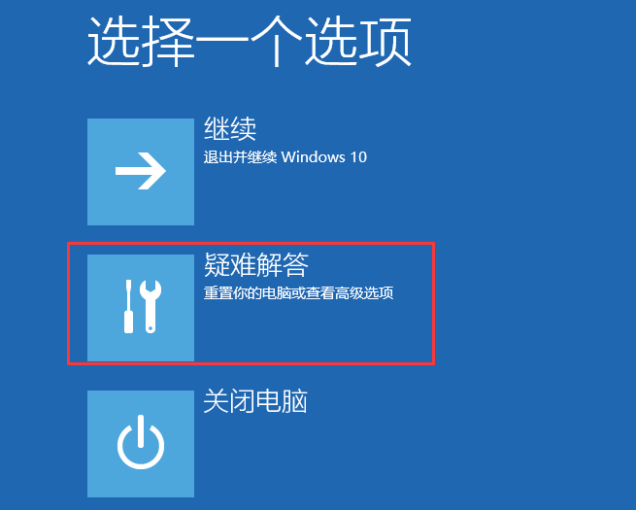
- 进入到疑难解答后，再选择“高级选项”，如下图：
When you select “Advanced options”,below:
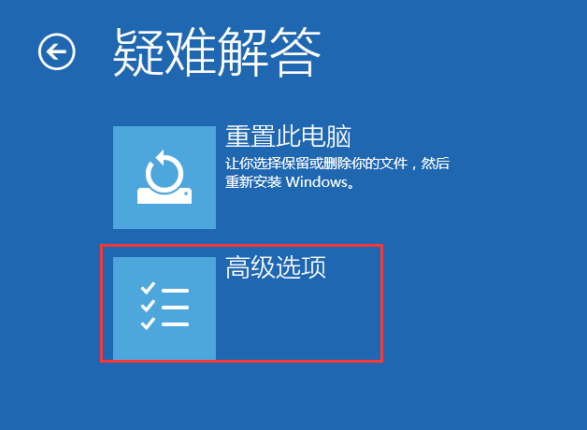
- 接下来，我们选择“启动设置”；
And then we select “Startup Settings”
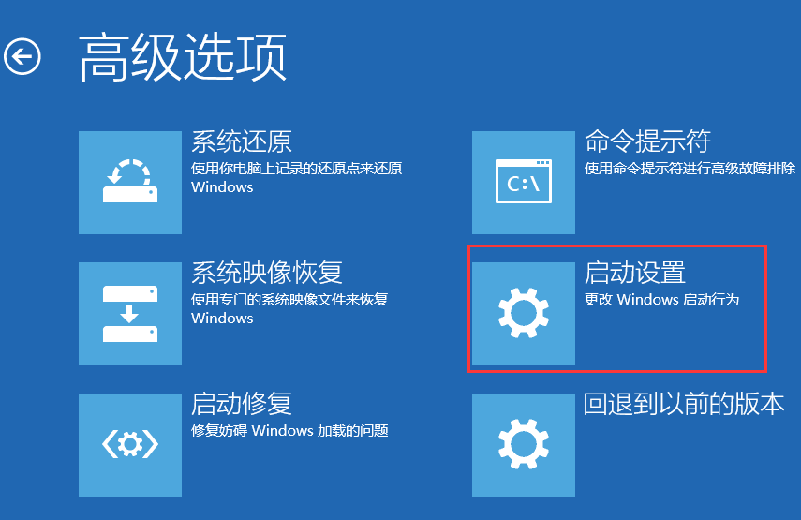
- 接下来在启动设置中，我们可以看到多选项（如禁用驱动程序强制签名），这时是不能选择的，Windows需要我们先重启来激活这些选项，我们点击重启即可
the next in the startup Settings, we can see many options (such as disable driver signature compulsory), is can't choose at this moment, we first restart Windows needed to activate these options, we click reboot
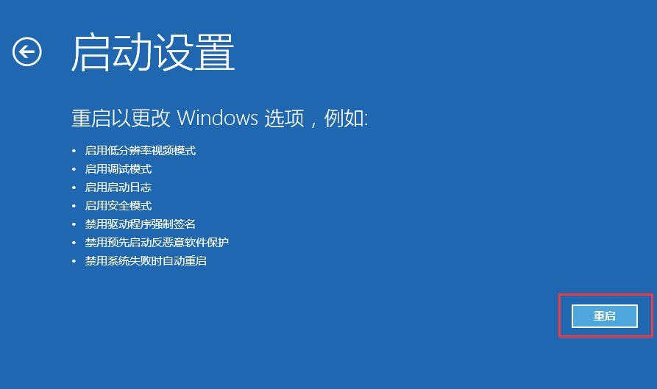
- 重启后，我们就可以看到众多的特殊启动模式选项了，其中也包括“禁用驱动强制签名”，我们可以按数字键来选择进入的系统，如按 7键；
After the restart, we can see many special boot mode options, including "disable driving force signature", we can press the number keys to select into the system, such as the seven key;
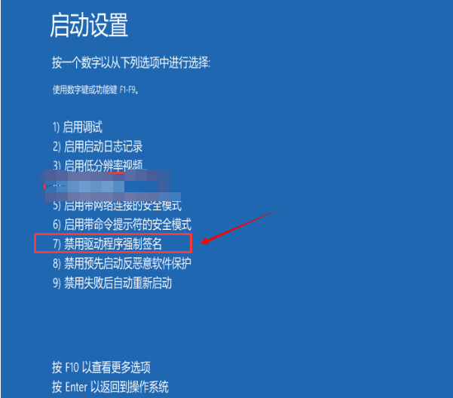
7、最后进入到禁用驱动强制签名模式，然后我们再安装驱动程序，就可以安装成功了！
Finally go into the driver mandatory signature pattern, then we could install driver,

